Part 1
- Draw the circuit symbols for the following components…
  - A switch open and a switch closed
  - A cell
  - A battery
  - A diode
  - A resistor
  - A variable resistor
  - An LED (light emitting diode)
  - A lamp
  - A fuse
  - A voltmeter
  - An ammeter
  - A thermistor
  - An LDR (light dependent resistor)
- Describe the difference between a series circuit and a parallel circuit.

- What is an electric current?

- Describe how the currents in a series circuit and a parallel circuit differ.

  - Draw a circuit diagram with a bulb, a switch and a cell
  - Add two components to show how you would measure the current and potential difference.
  - Label the two components from part b.

- State the equation that links charge flow, current and time.

- Calculate the current in a circuit if a charge of 4 C flows in 20 seconds.

- In a lightning bolt, a charge of 15 C flows and there is a current of 30,000 A. Calculate the duration of the lightning strike.

Part 2
- What is electrical resisitance?

- In a circuit if you keep the potential difference the same what will happen to the current as you increase the resistance?

- Write the equation that links, potential difference, current and resisitance.

- A current of 0.05A flows through an electrical device with a resisitance of 240 Ω. Calculate the potential difference.

- A lamp has current of 1.2 A flowing through it and a potential difference of 72 V electrical device with a resisitance of 240 Ω. Calculate the potential difference.

- What is a variable resistor?

- Describe the difference between a series circuit and a parallel circuit.

- What is an electric current?

- Which of the following current – potential difference graphs is for an ohmic conductor? Explain your answer.
- a. A student wants to draw a current – potential difference graph for a filament lamp. Draw a circuit that the student will need to set up to obtain the data needed to be able to draw the graph.

10. b. Draw the current– potential difference graph the student should obtain and explain why the graph has the shape you have drawn.
- Describe how the currents in a series circuit and a parallel circuit differ.

- Draw a fully labelled series circuit that contains a switch, a battery and two lamps.

- Calculate the resistance of the resistors in series shown in the diagram below.
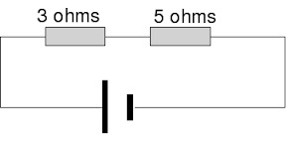
- Two resistors are placed in parallel as shown in the diagram below. Why will the maximum resistance of the circuit be less than 22 kΩ?
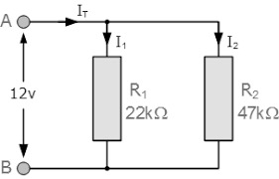

- a. What is the current in the main branch (I_{s}) of the circuit shown?
15. b. The cell in the circuit above supplies a potential difference of 9 V to the circuit. What is the potential difference across each lamp? Explain your answer.
- Describe three ways that electrical appliances can transfer electrical energy.

- Why do electrical devises heat up when they are switched on?

- Write the equation that links energy transfer, time, current and potential difference.

- A 12 V battery supplies a current of 1.2 A to a lamp for 130 seconds. Calculate the energy transferred.

- State the equation that links power, energy transferred and time. Include equation symbols and units.

- State the equation that links power, potential difference and current. Include equation symbols and units.

- State the equation that links power, current and resistance. Include equation symbols and units.

- What does a.c stand for?

- What does d.c stand for?

- Give an example of where a.c is used.

- Give an example of where d.c is used.
- Describe the difference between an alternating potential difference and direct potential difference. You may draw a sketch graph to help answer the question.

- What is the frequency and potential difference of mains electricity in the U.K?

- Copy and complete the table below for the wire in three core electrical cable.

- Explain why a live wire may be dangerous even when a switch in the mains circuit is open.

